Students’ Practical Trainings in the Bolnisi and Kazbegi Regions

The Department of Applied Geology of the Mining and Geological Faculty of the Georgian Technical University from 2003 year ensures the fulfillment of two geological field-training programs in the Bolnisi and Kazbegi regions.
During the practical trainings the students get acquainted with the two geologically different regions.

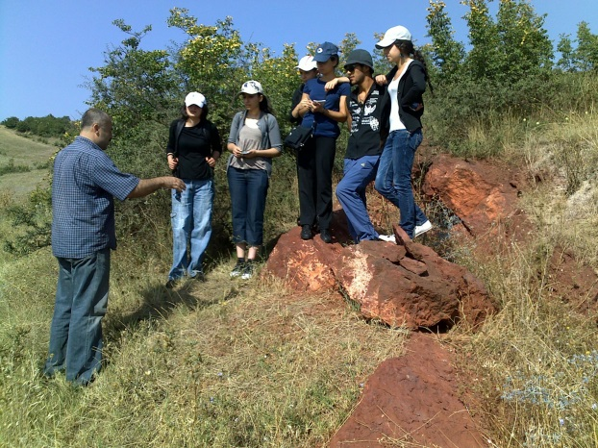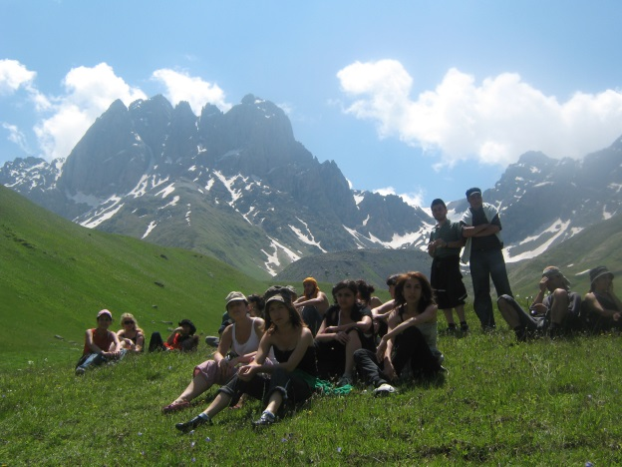

Geological Practical Training in the Kazreti Borough (the Bolnisi Region)

The Bolnisi region has been chosen due to geological and mineralogical factors. During the practical trainings the students stay at the scientific research base of the Acad. Sci. of Georgia where there are created good housing conditions for them.
The students get acquainted with the structural and general geology of the Region. The Bolnisi region is located on the Artvin-Bolnisi block that is built by Paleozoic crystal rocks, Mesozoic igneous and sedimentary rocks, Cainozoic intrusive bodies and lava flows of dolerite composition.
The Madneuli barite-copper-pyrite, gold and Farkhalo tuff operating mines are located in this Region. At these mines the students get acquainted with ores, ore minerals, gold-bearing quartzites and the methods of their beneficiation, methods of mining and processing of trim stones.

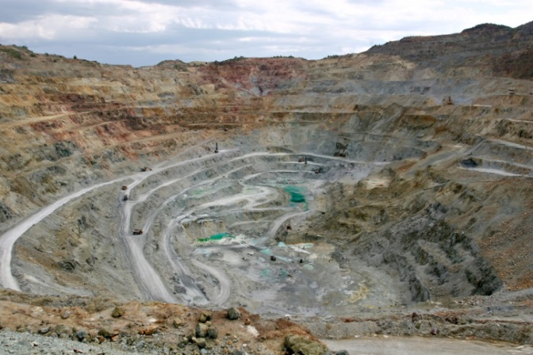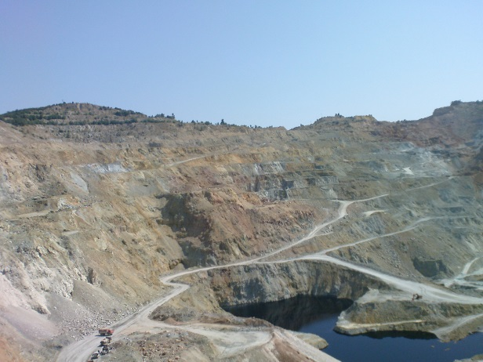
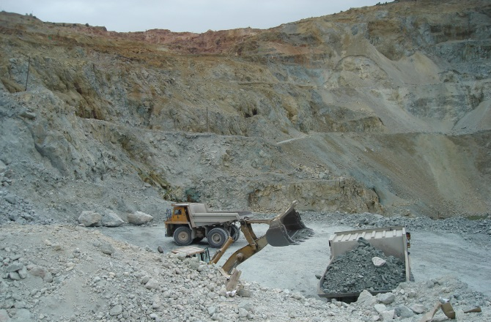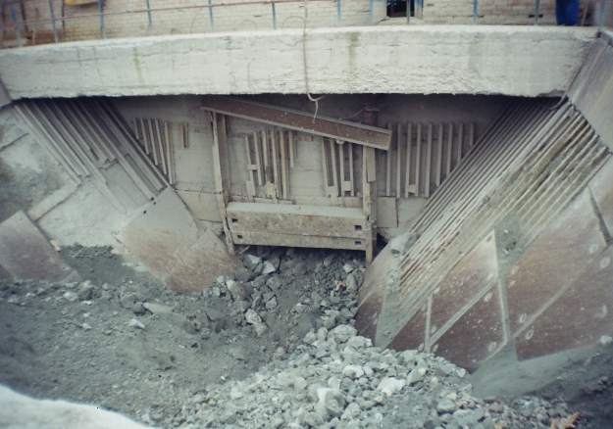
Mining and processing of copper in the barite-copper-pyrite ores

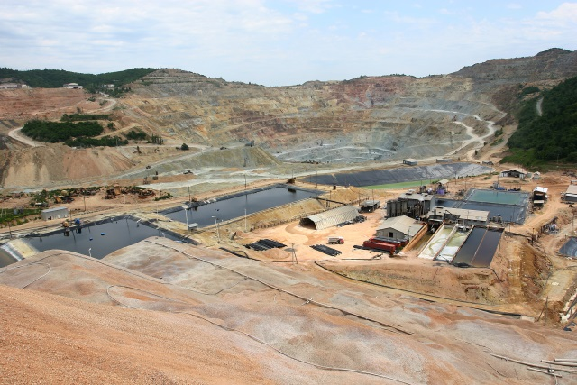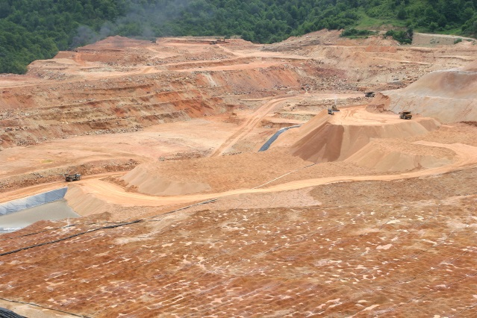

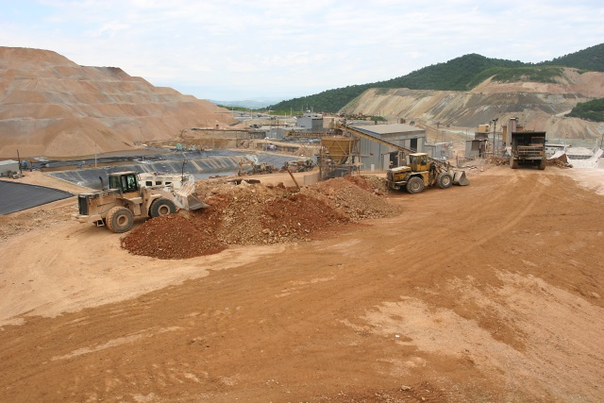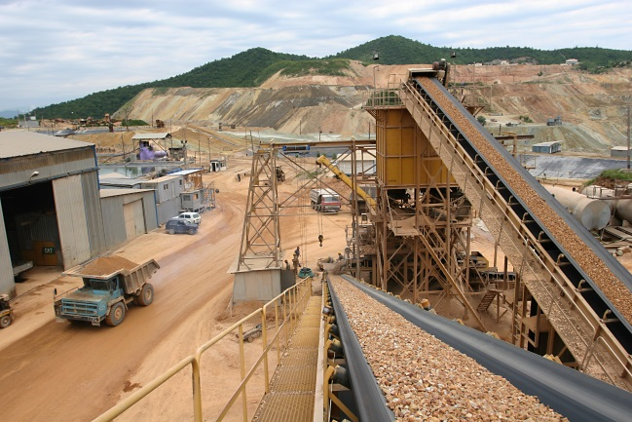
Mining and processing of gold in the secondary quartzites

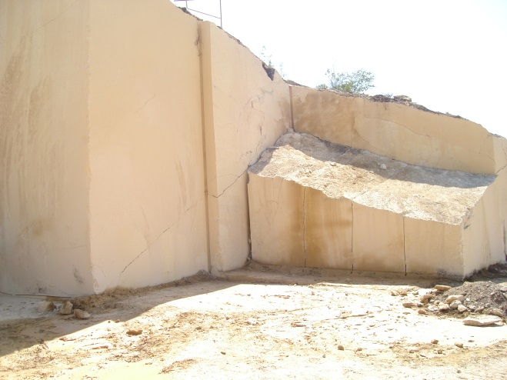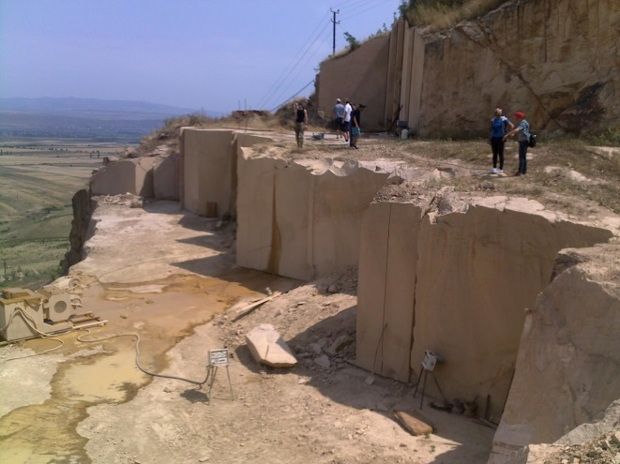

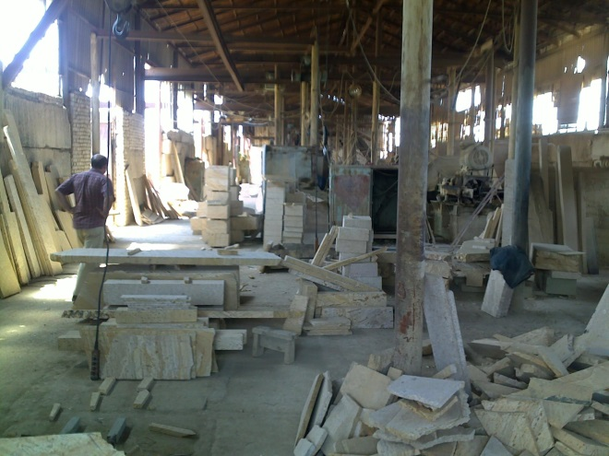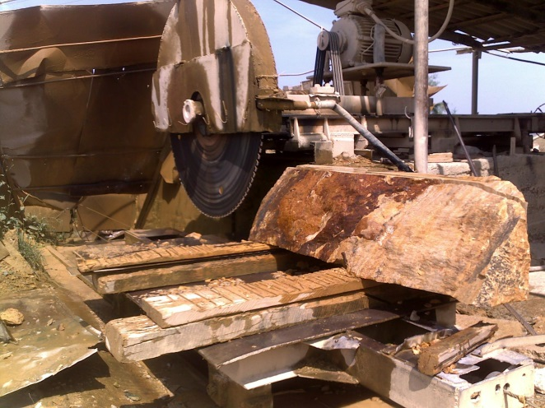
Mining and processing of tuff from the Farkhalo mine

Besides the geological diversity the practical training gives students the possibility to visit the significant archaeological monuments of the Region; among them the most important monuments are: the Bolnisi Sioni Cathedral, Tsugrugasheni church, Qveshi castle, Sulkhan-Saba Memorial Home, ruins of the former Dmanisi town, etc.

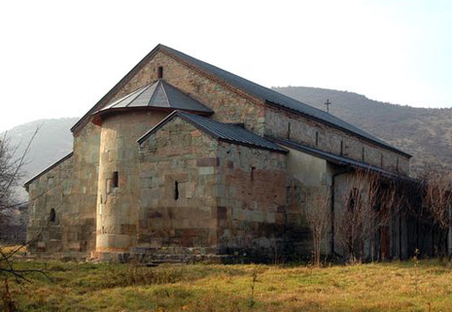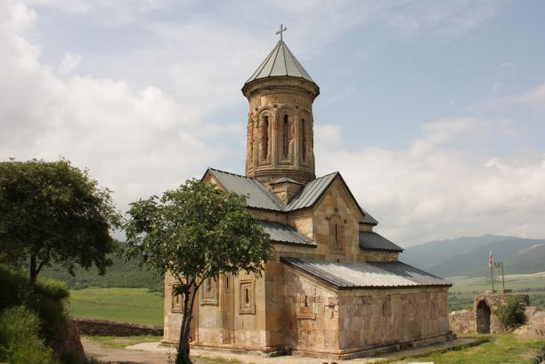

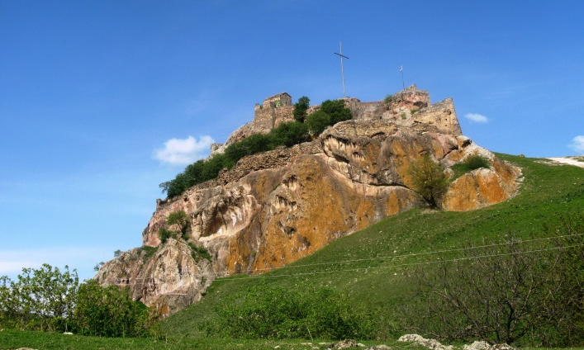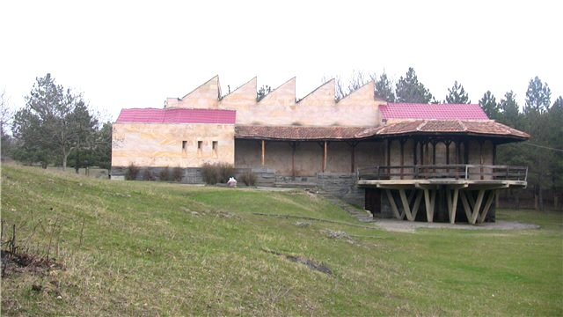

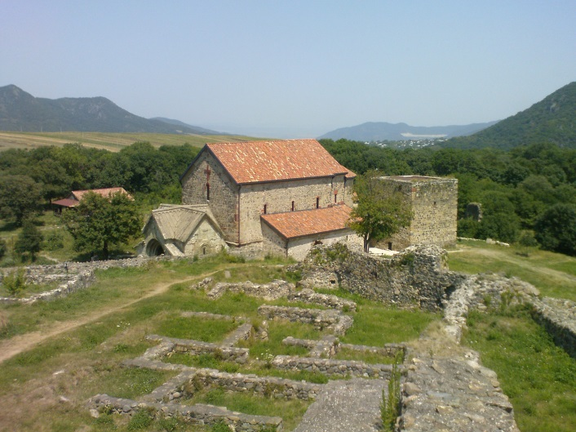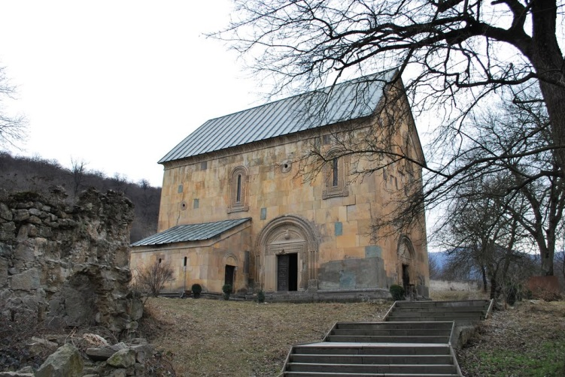
Historical-cultural monuments of the Bolnisi Region

Geological Practical Training in the Kzbegi Region

The Kazbegi Region is in the Folded System of the Greater Caucasus, where (the Daryal Pass) there crop out Paleozoic granitoids, Jurassic slates and in the southern part of the Region – Carbonaceous deposits. There is wide-spread Pliocene-Quarternary andesite and dacite igneous rocks.
The Kazbegi Region is interesting from both – geological and hydro-geological points of view.
In the Kazbegi region the students get acquainted with the volcanic centers and distinctly observed volcanic flows, fan-shaped, spherical and columnar partitioning and forms of weathering, the diversity of mountainous rivers and mineral water springs.
During their practical trainings the students learn much about the remarkable cultural sights of the Region – churches and monasteries, memorial homes, castles, etc.

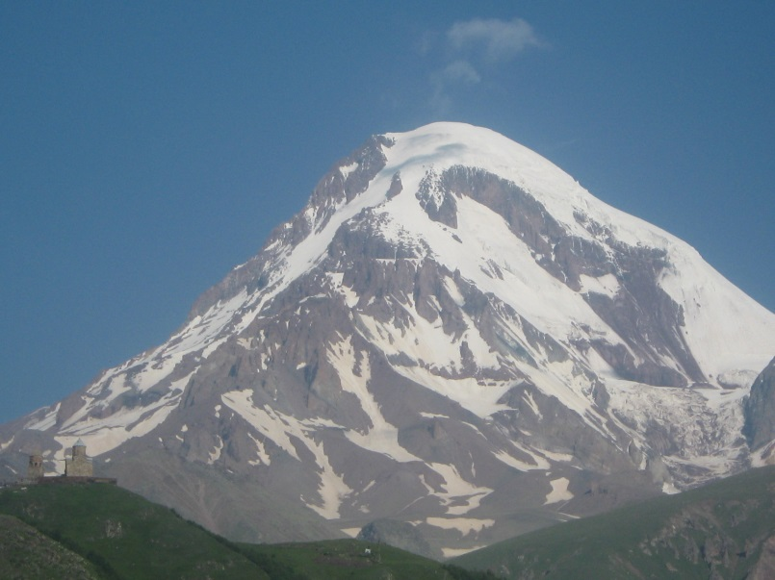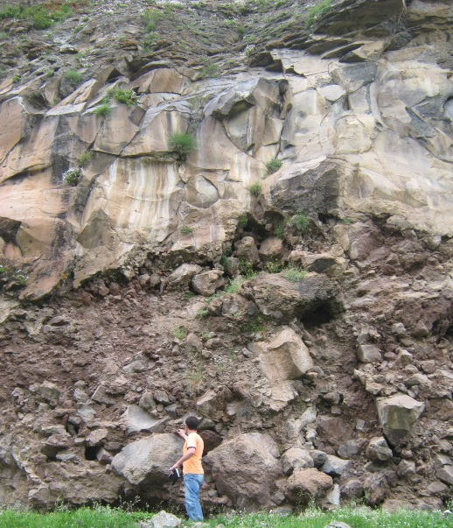
Volcanic center and volcanic flow

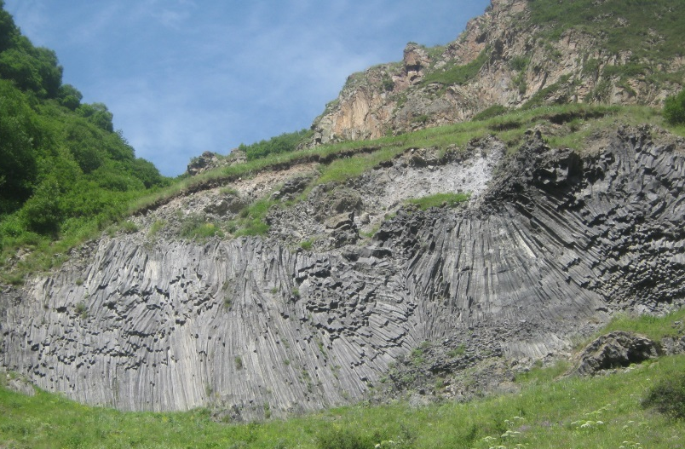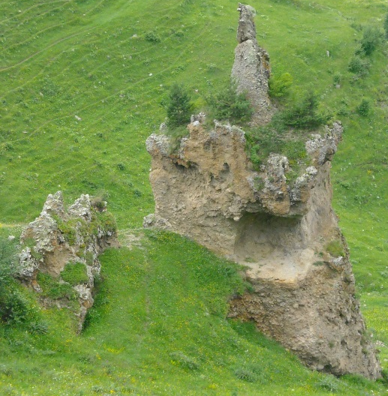
Fan-like partitioning and form of weathering

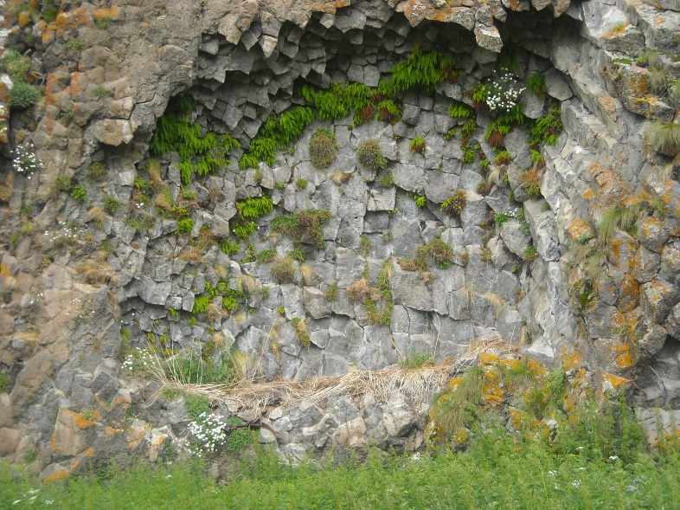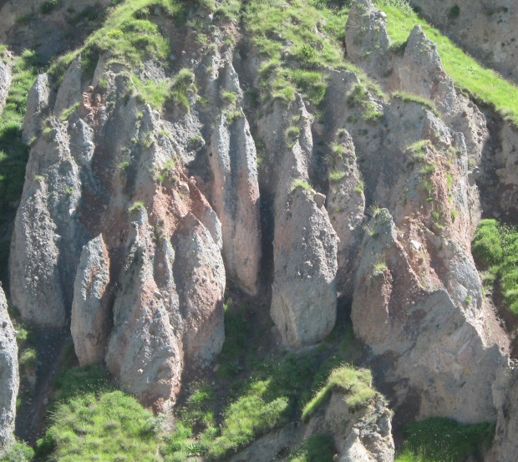
Column-like partitioning and form of weathering

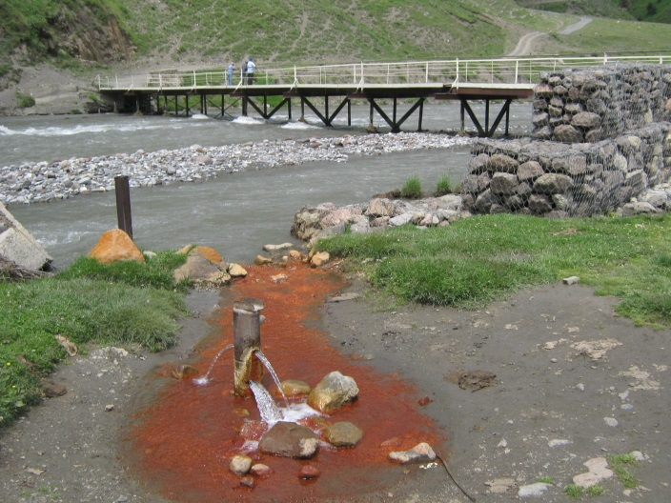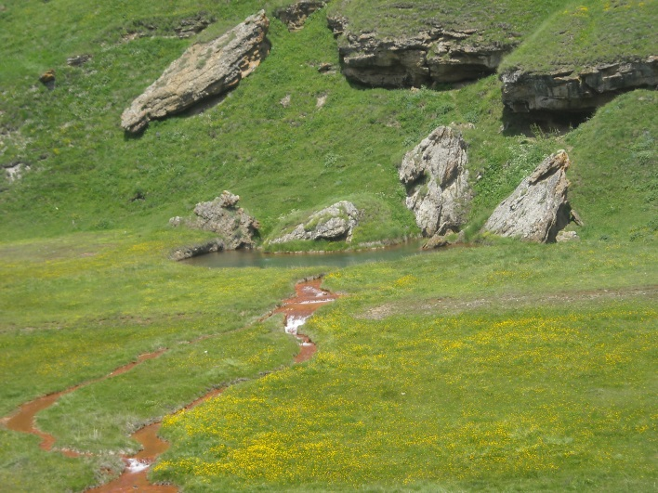
Springs of mineral waters

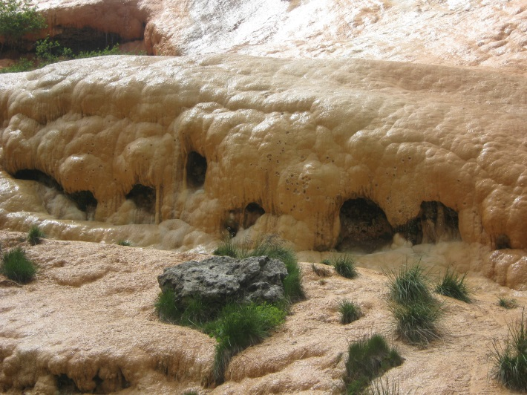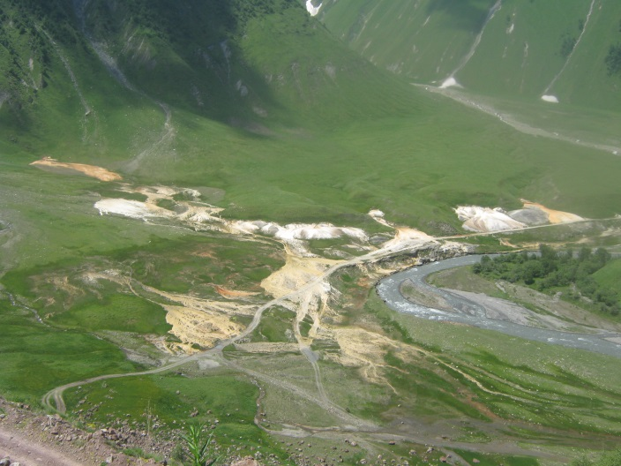
Travertines

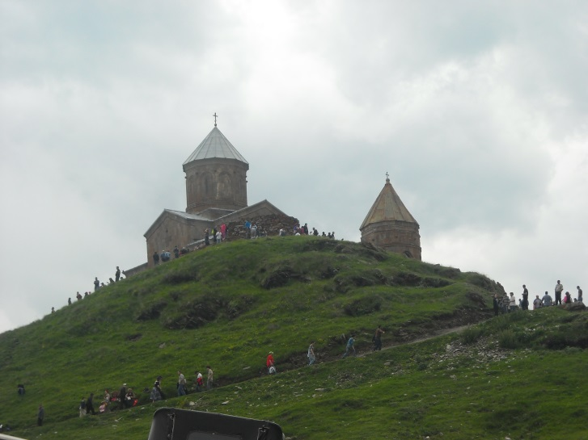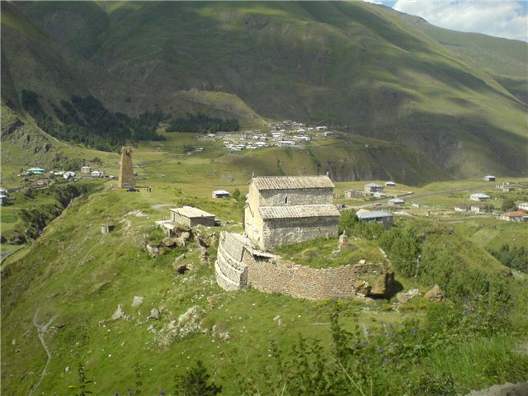

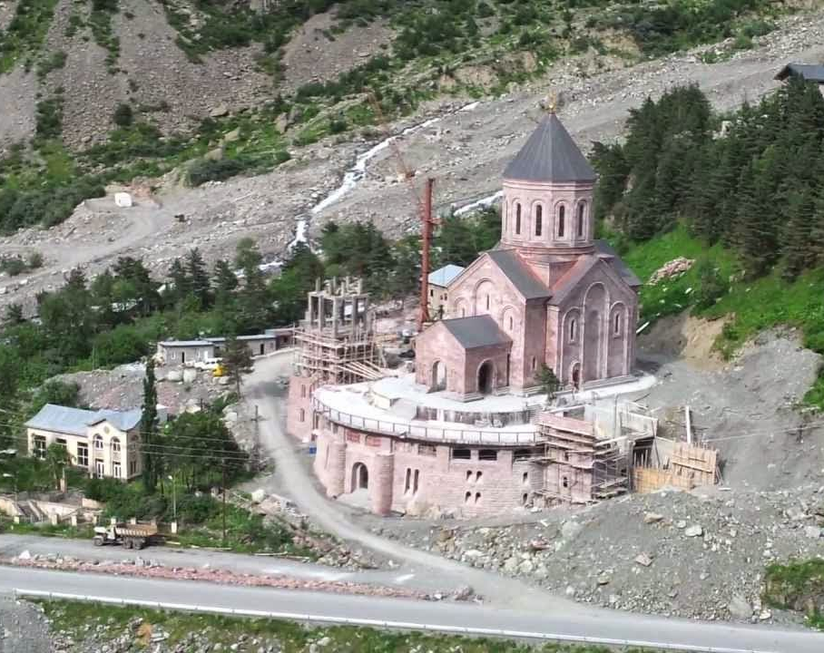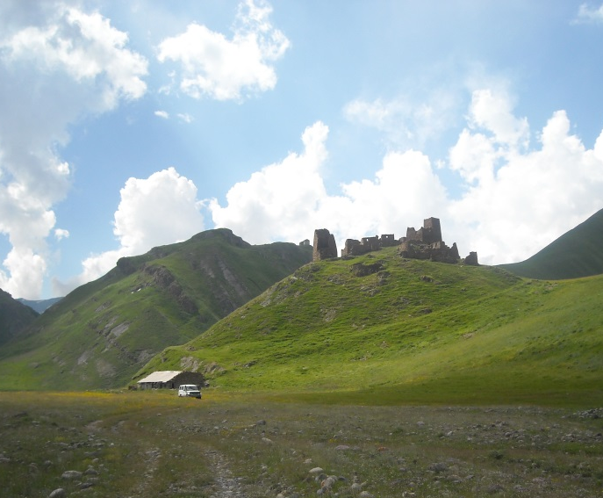

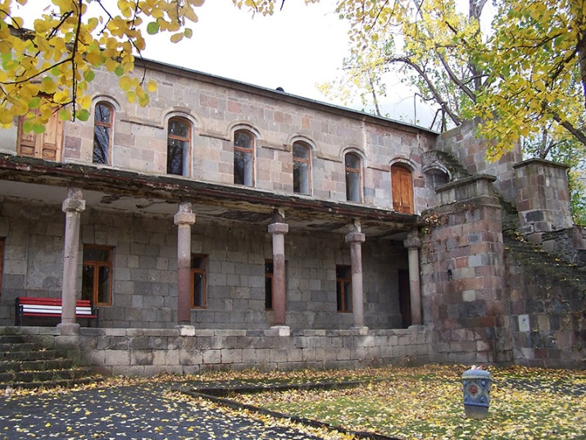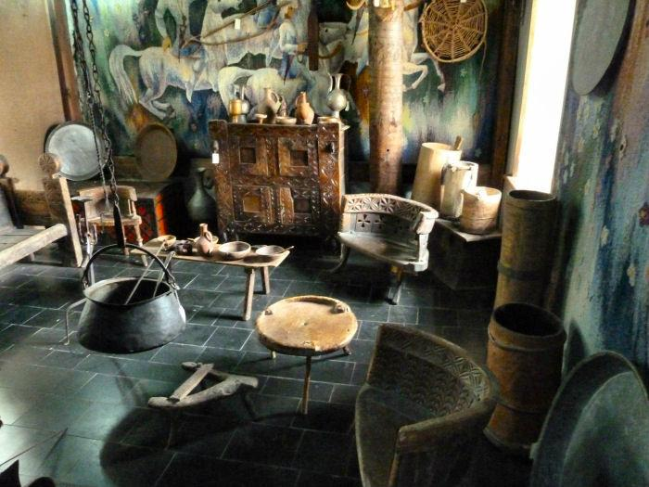
Historical-cultural monuments of the Kazbegi Region

